Navigate to EC2 and click on Launch Instance

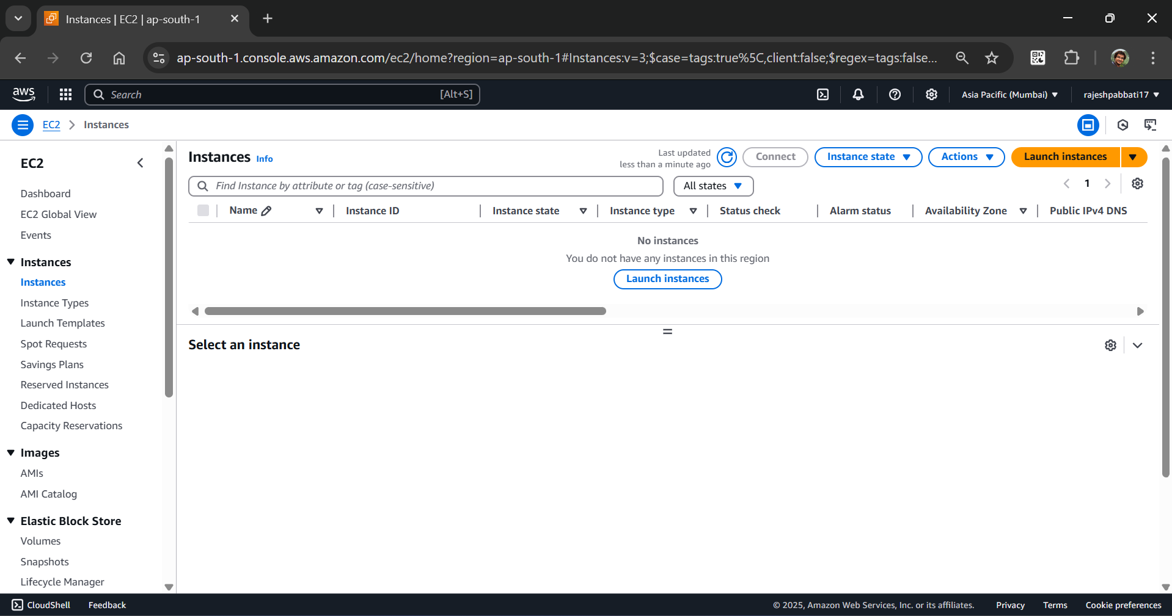

Give Name

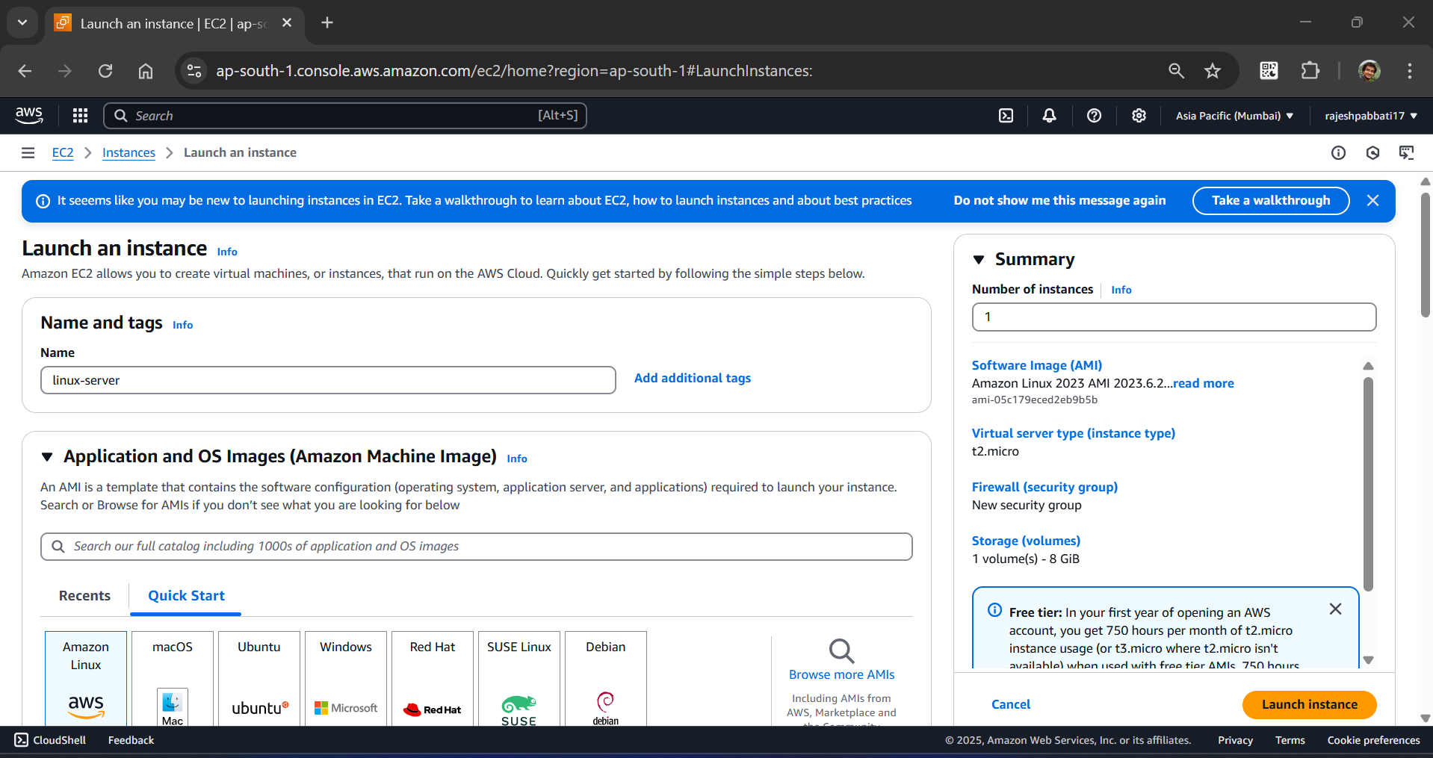

Select Amazon Linux AMI and default Instance type

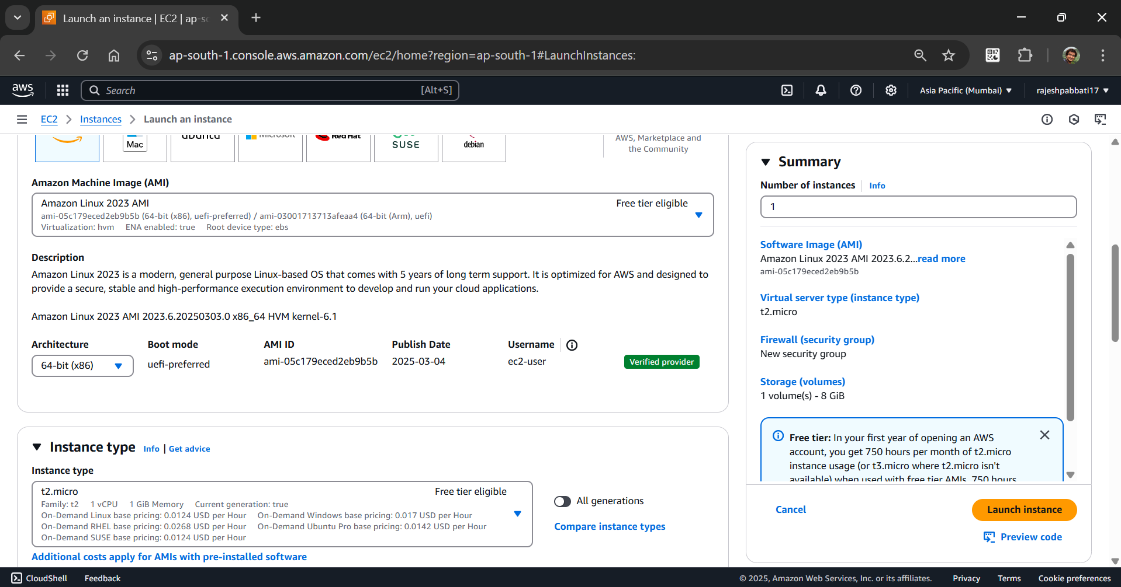

Select key pair and default network settings and click on Launch Instance

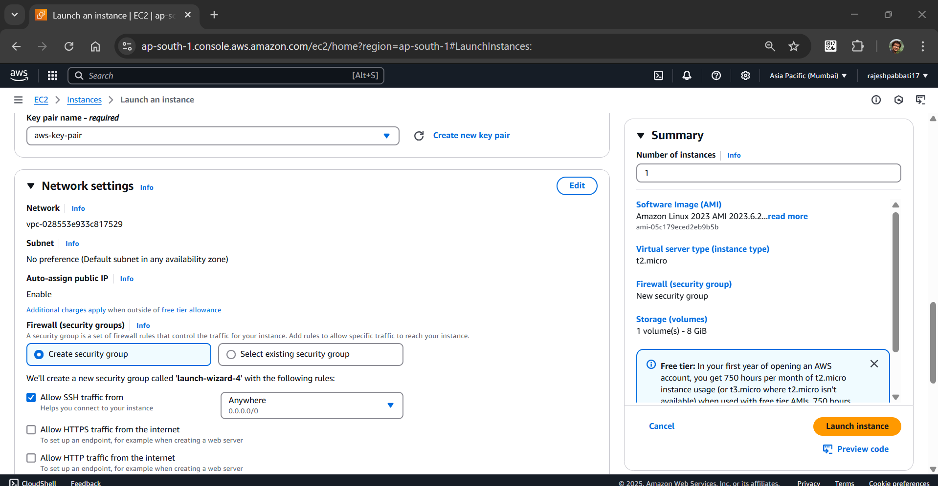

Instance is running and select the instance and click on connect

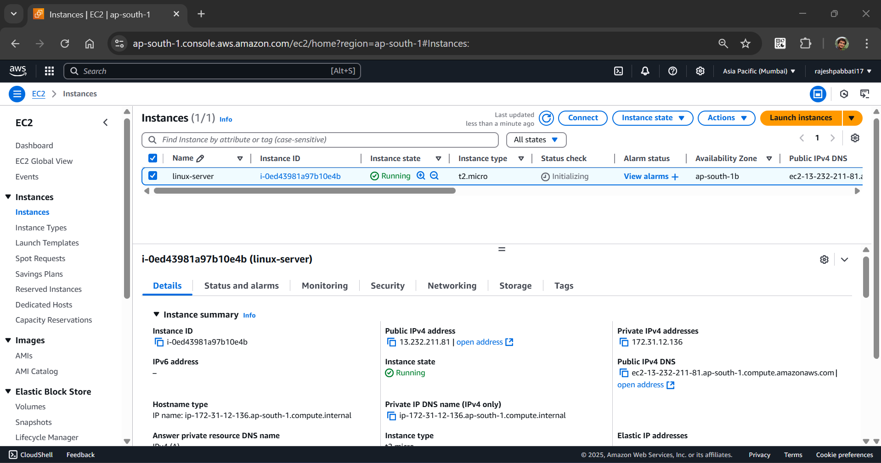

Go to the third tab SSH client and select highlighted in the below screenshot and copy

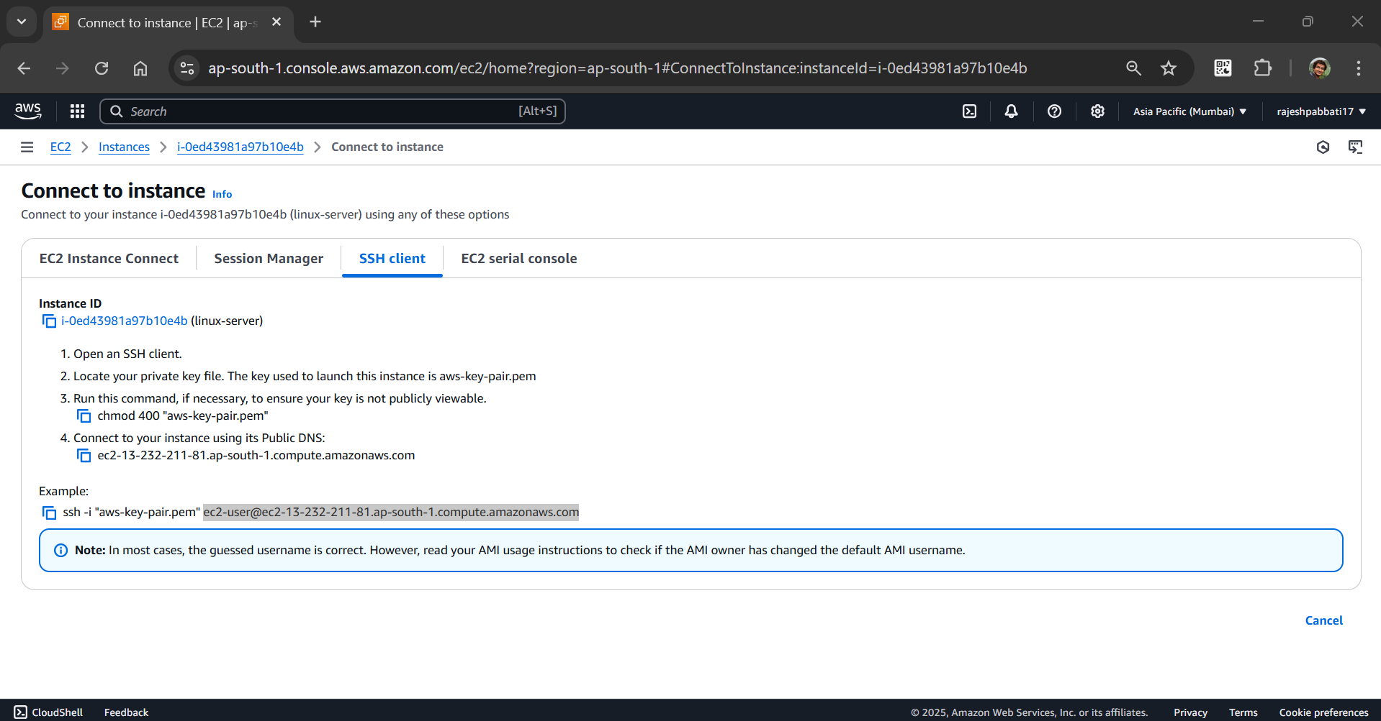

Open the putty and paste the copied in previous step.

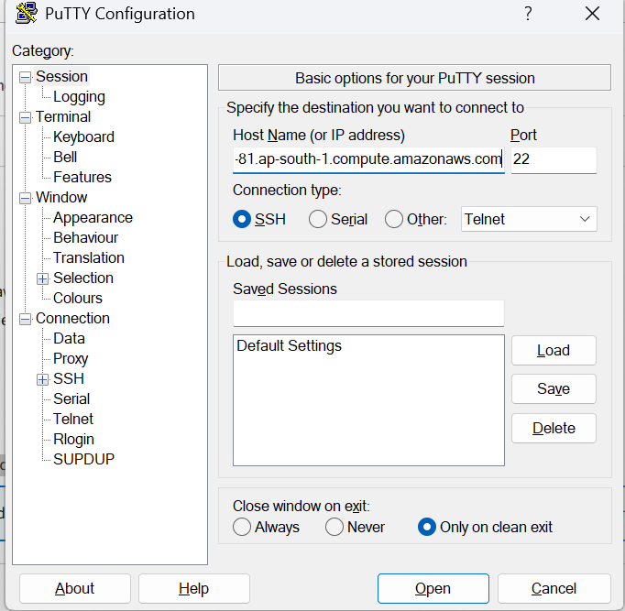

Navigate to Connection 🡪 SSH 🡪 Auth 🡪 Credentials. Browse and select ppk key pair and click on open

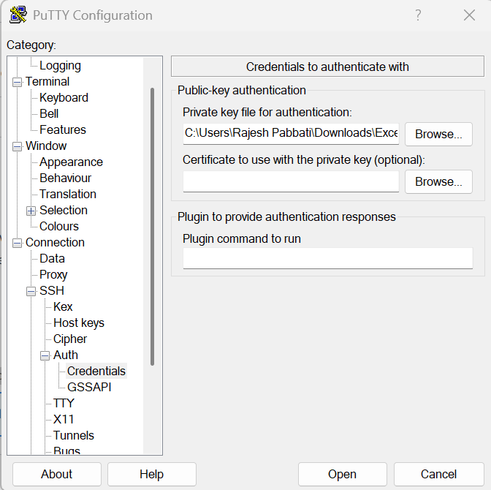

Connected to amazon linux instance

